1. SIGNAL GENERATION AND BASIC SIGNAL OPERATIONS

Experiment 1.1
Generation of Continuous Time Signals

Aim
To verify the generation of a sinusoidal signal with a specific frequency, amplitude, and phase shift using MATLAB. The Aim is to ensure that the signal generator can accurately produce a sinusoidal waveform with the desired parameters.

Apparatus Required
PC with MATLAB.

Program:
% Generation of Continuous Time Signals clc;
clear; close all;
% Time axis t = -5:0.01:5;
% Continuous-time sine signal x = sin(2*pi*t);
% Plotting figure;
plot(t, x, 'LineWidth', 2); grid on;
title('Continuous Time Sine Signal'); xlabel('Time (seconds)'); ylabel('Amplitude');

Output Waveform:

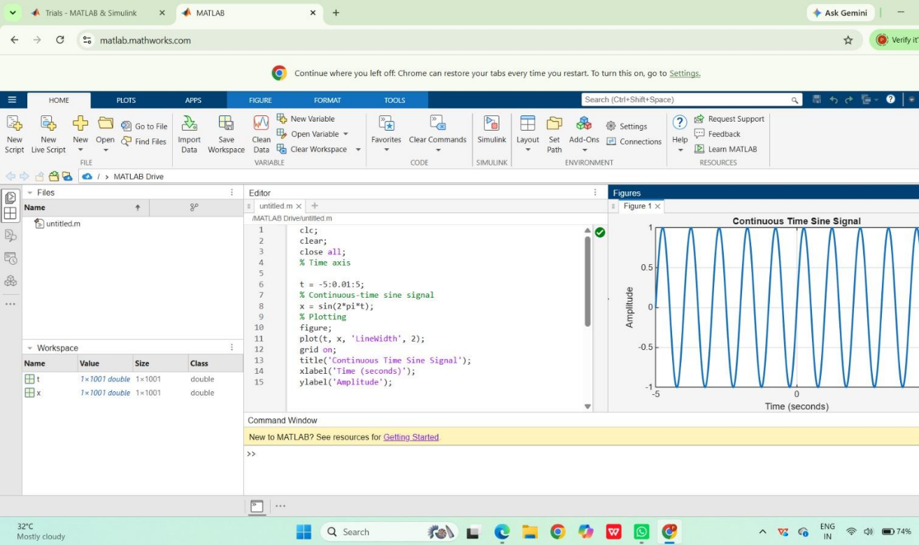

Result:
This test case validates that the signal generator can produce a sinusoidal waveform with the specified frequency, amplitude, and phase shift.

Experiment 1.2
Generation of Discrete Time Signals

Aim:
To generate and verify a discrete-time unit impulse signal using MATLAB. The Aim is to ensure that the signal generator can accurately produce an impulse signal at a specified time index, which is crucial for analyzing and understanding the behavior of discrete-time systems.

Apparatus Required
PC with MATLAB.

Program:
% Generation of Discrete Time Signal clc;
clear; close all;
% Discrete-time index n = -10:10;

% Discrete-time sinusoidal signal x = sin(0.2*pi*n);
% Plotting figure;
stem(n, x, 'filled'); grid on;
title('Discrete Time Sinusoidal Signal'); xlabel('Sample Index (n)'); ylabel('Amplitude');

Output Waveform:
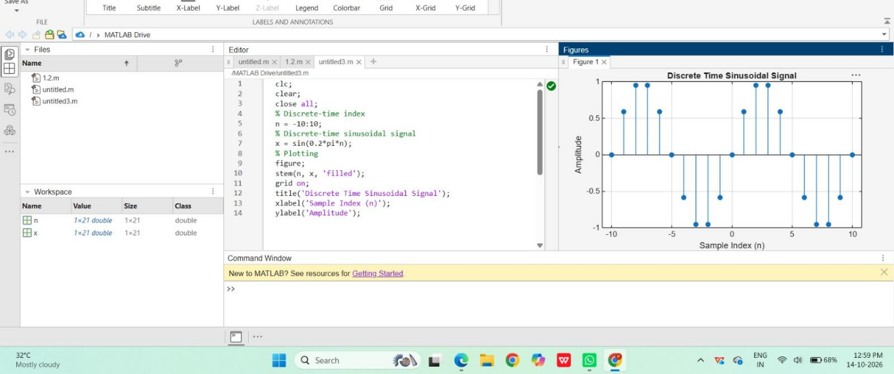
Result:
This test case validates that the signal generator can accurately produce a discrete-time unit impulse signal at a specified index, which is essential for analyzing the response of discrete-time systems.

Experiment 1.3
Generation of Triangular and Sawtooth Signals

Aim
Generate and plot triangular and sawtooth signals.

Apparatus Required

PC with MATLAB.

Program (MATLAB)
% Generation of Triangular and Sawtooth Signals clc;
clear; close all;
% Time axis t = 0:0.01:2;
% Sawtooth Signal
x1 = sawtooth(2*pi*t);
% Triangular Signal
x2 = sawtooth(2*pi*t,0.5);
% Plotting figure; subplot(2,1,1);
plot(t,x1,'LineWidth',2); grid on;
title('Sawtooth Signal'); xlabel('Time (s)'); ylabel('Amplitude'); subplot(2,1,2); plot(t,x2,'LineWidth',2); grid on;
title('Triangular Signal'); xlabel('Time (s)'); ylabel('Amplitude');

Output Generated Graph

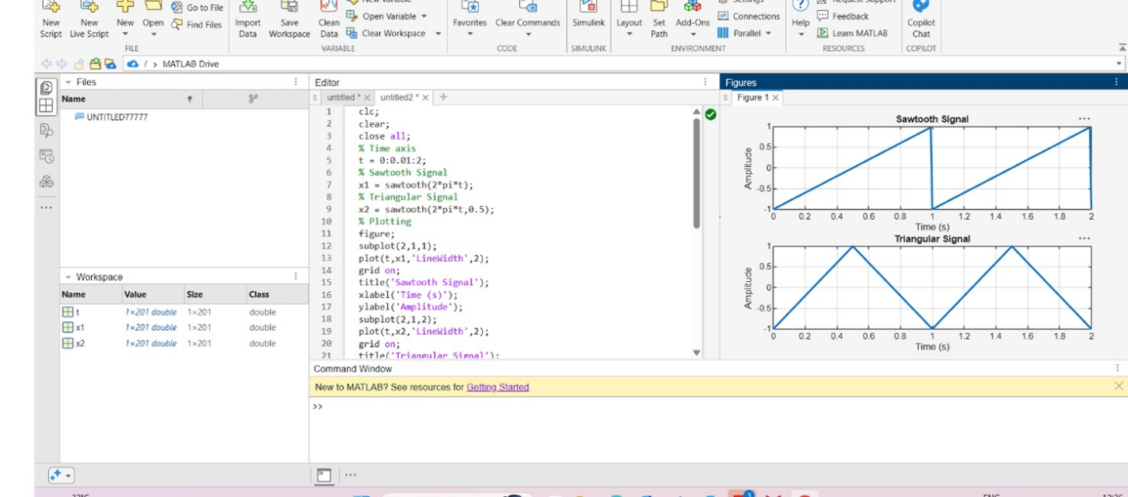

Result
Triangular wave has equal rise and fall; sawtooth shows sharp drop and gradual rise.

Experiment 1.4
Step and Ramp Functions (Continuous & Discrete)

Aim
Generate and plot unit impulse, unit step, and ramp functions.

Apparatus Required
PC with MATLAB.

Program (MATLAB)
% Step and Ramp Functions (Continuous & Discrete) clc;
clear; close all;
%% Continuous-Time Signals t = -5:0.01:5;
% Continuous Unit Step Function u = double(t >= 0);
% Continuous Ramp Function

r = t .* (t >= 0);
%% Discrete-Time Signals n = -5:5;
% Discrete Unit Step Function ud = double(n >= 0);
% Discrete Ramp Function rd = n .* (n >= 0);
%% Plotting figure; subplot(2,2,1);
plot(t,u,'LineWidth',2); grid on;
title('Continuous Unit Step Function'); xlabel('Time (t)');
ylabel('Amplitude'); subplot(2,2,2); plot(t,r,'LineWidth',2); grid on;
title('Continuous Ramp Function'); xlabel('Time (t)'); ylabel('Amplitude'); subplot(2,2,3);
stem(n,ud,'filled'); grid on;
title('Discrete Unit Step Function'); xlabel('Sample Index (n)'); ylabel('Amplitude'); subplot(2,2,4);
stem(n,rd,'filled'); grid on;
title('Discrete Ramp Function'); xlabel('Sample Index (n)'); ylabel('Amplitude');

Output Generated Graph
